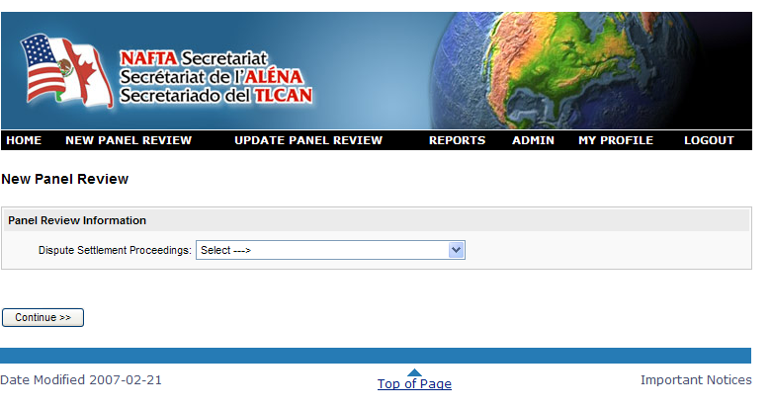

NAFTA Registry Information
System (RIS)

User guide

2013

Registry
Information
System
User Guide
Revised: July 2013

https://registry.nafta-sec-alena.org/

NAFTA Secretariat  Canadian Section  111 Sussex Drive  5th Floor  Ottawa, Ontario  Canada K1N 1J1  Canadian Section  Telephone No.: 343-203-4274  Fax No.: 613-992-9392  e-mail: webmaster@nafta-alena.gc.ca | NAFTA Secretariat  Mexican Section  Blvd. Adolfo López Mateos 3025, 2º Piso  Col. Héroes de Padierna  C.P. 10700, México, D.F.  Mexican Section  Telephone No.: 52-55-56-29-9630  Fax No.: 52-55-56-29-9637  e-mail: naftamexico@nafta-sec-alena.org | NAFTA Secretariat  U.S. Section  14th Street & Constitution Avenue, N.W.  Room 2061  Washington, D.C. 20230  U.S. Section  Telephone No.: 202-482-5438  Fax No.: 202-482-0148  e-mail: usa@nafta-sec-alena.org
Table of Contents

1.0 Registry Information System Overview 4
2.0 User Account Types 4
2.1 Super Administrator Role (SuperAdmin) 4
2.2 Administrator Role 4
2.3 PowerUsers Role 5
2.4 Viewer Role 5
3.0 Case Management 5
3.1 Create New Panel Review 5
3.1.1 Add Participants 8
3.1.2 Assign Counsels 10
3.1.3 Add Panelists 12
3.1.4 Assign Assistants 15
3.1.5 Add “Request for Panel Review” 17
3.2 Update Panel Review 17
3.2.1 Document Management 18
3.2.1.1 Add Document 19
3.2.1.2 Add Decision 20
3.2.1.3 Modify Document 21
3.2.1.4 Delete Document 22
3.2.2 Timeline 22
3.2.3 Status 23
3.3 Delete Panel Review 25
4.0 Lists Management Modules 26
4.1 “List Management” and “Participant Management” 26
4.1.1 List Management 26
4.1.1.1 Add Counsels, Panelists and Assistants 27
4.1.1.2 Account Management for NAFTA Secretariat Employees 28
4.1.2 Participant Management 30
4.1.2.1 Add Participants 30
4.1.2.2 Modify Participants 31
5.0 Reports 32
6.0 Application Options 33
7.0 Participant Requests 35
8.0 Unlock User Accounts 35
9.0 Recycle Bin 36
10.0 Support 36

1.0 Registry Information System Overview

The Registry Information System (RIS) has been developed to store data and to provide reporting tools for panel reviews relating to NAFTA and FTA (Canada-USA /USA-Canada).

2.0 User Account Types

Depending on the role requirements, a user is provided with one of four user types. The following section describes the differences between each account type (under the “List Management” module).

Please note that in order to setup an account, future users must contact their national section Administrator. Typically the RIS users are associated with one of the following first three roles:

2.1 Super Administrator Role (SuperAdmin)

Super Administrators have full access to the RIS. Super Administrators can:
- create new panel reviews for any country;
- update panel reviews for any country;
- delete panel reviews as required and remove them from the “Recycle Bin”;
- configure the RIS application settings through the “Application Options” module;
- add and modify individuals within the “List Management” and “Participant Management” modules;
- create RIS user accounts and regenerate new passwords.
- generate RIS reports; and
- modify their profile.

2.2 Administrator Role

Administrators have the following RIS rights:
- create new panel reviews for only the country that they have been assigned;
- update panel reviews for only the country they have been assigned;
- delete panel reviews as required and remove them from the “Recycle Bin”;
- configure the RIS application settings through the “Application Options” module;
- add and modify individuals within the “List Management” and “Participant Management” modules;
- create RIS user accounts and regenerate new passwords.
- generate RIS reports; and
- modify their profile.

2.3 PowerUsers Role

PowerUsers have the following RIS rights:
- create new panel reviews for their respective national sections only;
- update panel reviews for their respective national sections only;
- add and modify individuals within the “List Management” and “Participant Management” modules;
- generate RIS reports; and
- modify their profile.

2.4 Viewer Role

All other users (Assistant, Counsel, Panelist and Party), should it be required, could be provided with a “read-only” access to the RIS. Although these users cannot create/update/delete panel reviews, manage the “List Management” or the “Participant Management” databases, they can view information related to panel reviews and download (not upload) any document listed on a docket sheet. Furthermore, these users can update their own profiles.

3.0 Case Management

3.1 Create a New Panel Review

Step One

To initiate the process of creating a new panel review, from the homepage, select “Create New Panel Review”.
Set the language preference.

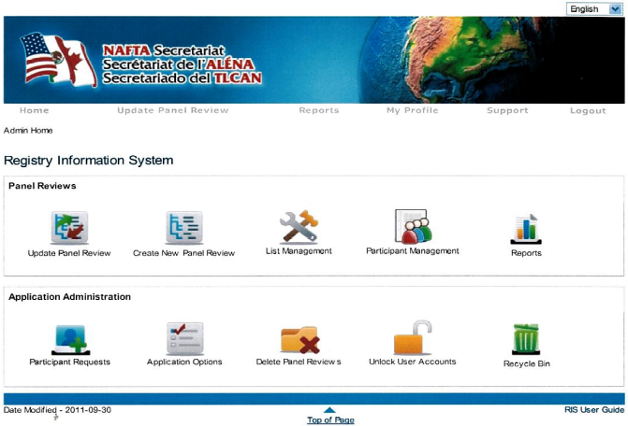

Upon selecting the icon, the following screen will be displayed:

Brings users to the last active module, not necessarily to the last screen.

Step Two

All of the fields on this screen are mandatory:
- Select the appropriate panel review type from the “Dispute Settlement Proceedings” drop down menu. The screen will now refresh based on the selected dispute settlement proceeding.
- To continue, data must be supplied for each category (use scroll down arrows to make a selection).
- At this point, note that only one language is required for the “Panel Review Title”. Translations should be added as soon as they become available.
- “Save”.

Step Three

When step two is completed, the panel review is now created in the RIS and the
following three actions happen simultaneously:
- the panel review number is automatically assigned. Note that the panel review number cannot be changed after it has been assigned;
- the timeline is generated; and
- the “Panel Review Requests”, under the “What’s New?” section of the NAFTA Secretariat website, is updated to indicate the panel review number, the request date and titles.

The figure below is presented upon completion of step two. Verify the information displayed, complete the “Final Determination Information” section, if required, and “Save”.
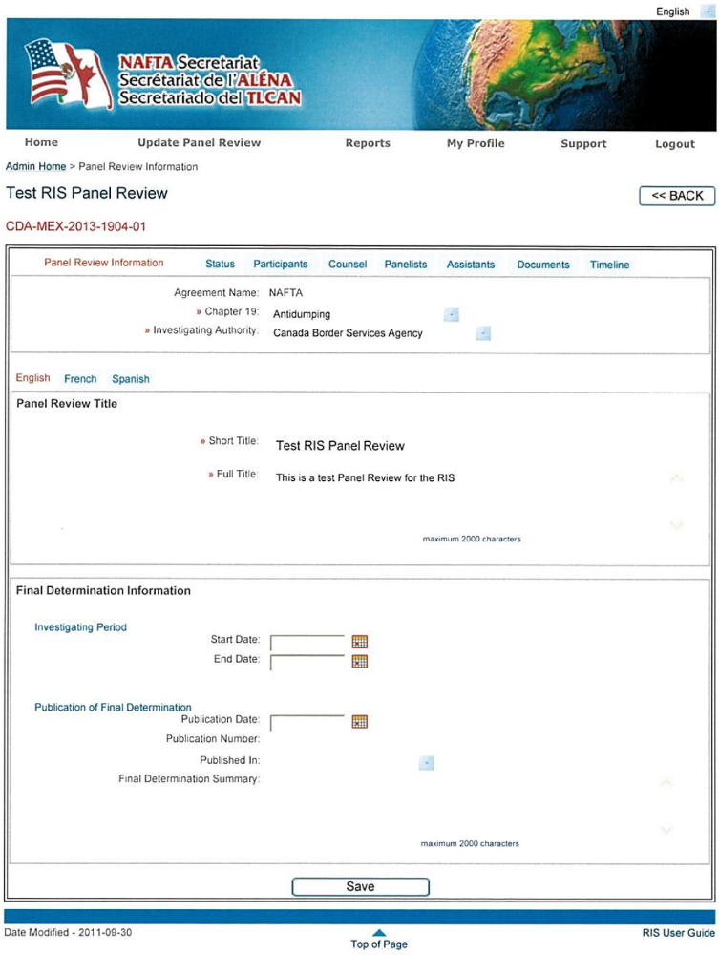
The “Spell Check” feature depends on the web browser used to open the RIS application.

Toggle between different data collection tabs at any time. The active tab is highlighted in orange.

The panel review title and number are displayed at the top of the screen.

Step Four

Now that the preliminary information for this panel review has been created and saved into the RIS, the user can begin adding participants, counsels, panelists and assistants.

***Note that each participant must be previously entered into the “Participant Management” database. Furthermore, counsels, panelists and assistants must be previously entered into the “List Management” database before accessing these areas. If these individuals have not been entered into their respective management modules, please refer to Section 4.0 of this user guide.

Step Five

Add all active members associated with the panel review. Note that the following four modules are very similar in their basic characteristics.

3.1.1 Add Participants

To add a participant to a panel review, select the “Participant” tab. The following screen will be presented as per the figure below. Select “Add Participant”.
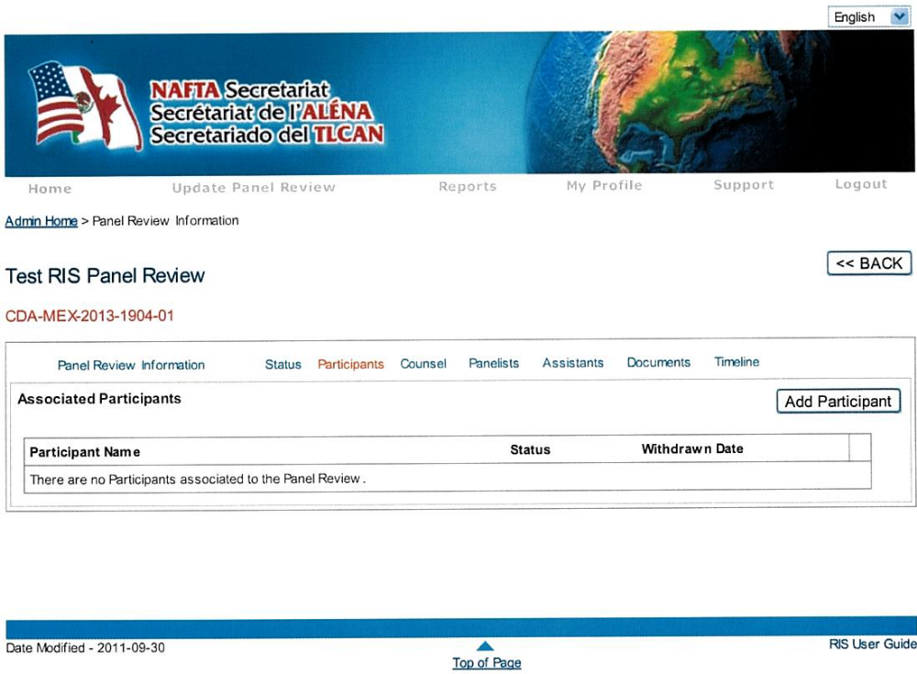

The name of a participant can be located by entering their first or last name into the “Search” field and by clicking on the magnifying glass to launch the search. To associate the participant to the panel review, select the checkbox and press “Add Participant”.
If the participant does not appear on the list provided, the participant profile must first be entered into the RIS by accessing the “Participant Management” module. Please refer to Section 4.0 – Lists Management Modules for instructions on how to perform this action.

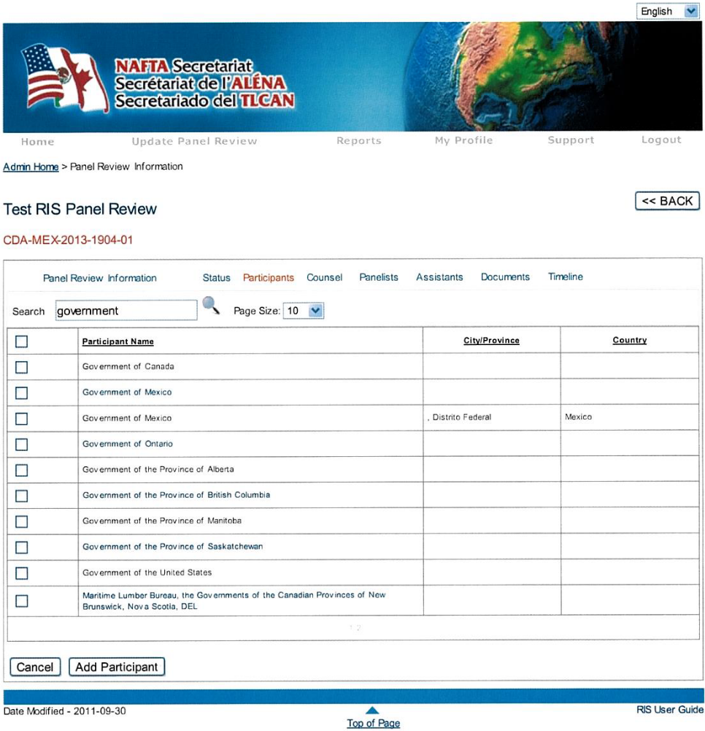
Type full or partial name and click
on the magnifying glass to automatically refresh the list, all possibilities will be displayed.

Profile Details

Government of Canada

Address

Office Telephone: N/A
Home Telephone: N/A
Fax: N/A
Email Address: N/A

Alternate Address: N/A

Select the appropriate participant via the select box and then press “Add Participant”.

Note that users can also place their mouse on any name within RIS to view additional profile details.

The participant selected will now appear within the “Participant” tab as per the figure below:

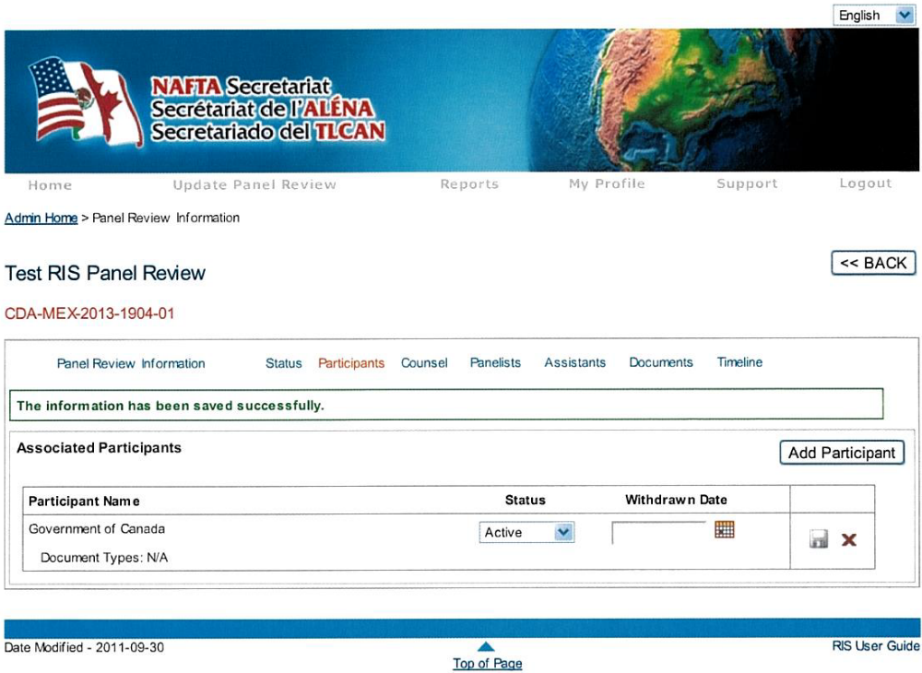
Notice that “Government of Canada” is now listed as a participant.

Additional participants can be added by selecting the “Add Participant” button.

To remove a participant that was added by mistake, click on the “X” in the last column. This action will only remove the participant name from the list of participants associated with this panel review. The participant’s profile will remain part of the “Participant Management” database.

3.1.2 Assign Counsels

The first step to assign a counsel to a participant is to ensure that at least one participant has been associated to the panel review and then select the “Counsel” tab. The following screen will be presented:

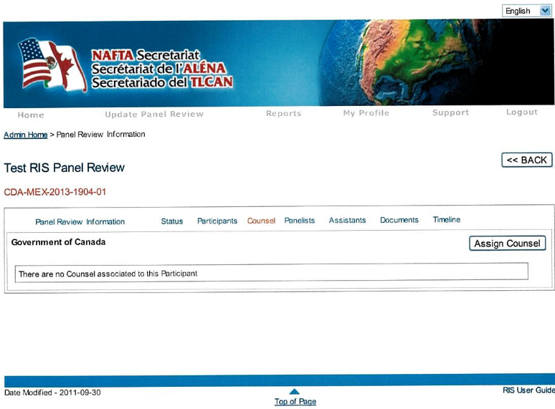
To assign a counsel for this participant, select the “Assign Counsel” button.

To assign the counsel for the “Government of Canada” select the “Assign Counsel” button. The following screen will be presented as per the figure below.

Type full or partial name and click
on the magnifying glass to automatically refresh the list, all possibilities will be displayed.

Select the appropriate counsel via the select box and then press “Assign Counsel”.

Indicate if the counsel is considered the lead or not.

Profile Details

Roberto Acuña Maldonaldo

Address

Office Telephone: N/A
Home Telephone: N/A
Fax: N/A
Email Address: N/A

Alternate Address: N/A

Note that users can also place their mouse on the name of an individual to view their profile.

Again, the name of a counsel can be located by entering their first or last name into the “Search” field and by clicking on the magnifying glass to launch the search. Once the counsel is located, select the checkbox and then press “Assign Counsel”.

If the counsel does not appear on the list provided, the counsel profile must first be entered into the RIS by accessing the “List Management” module. Please refer to Section 4.0 – Lists Management Modules for instructions on how to perform this action.

Upon selecting the “Assign Counsel” button, the user will be redirected back to the counsel main screen and the individual selected will now be associated:

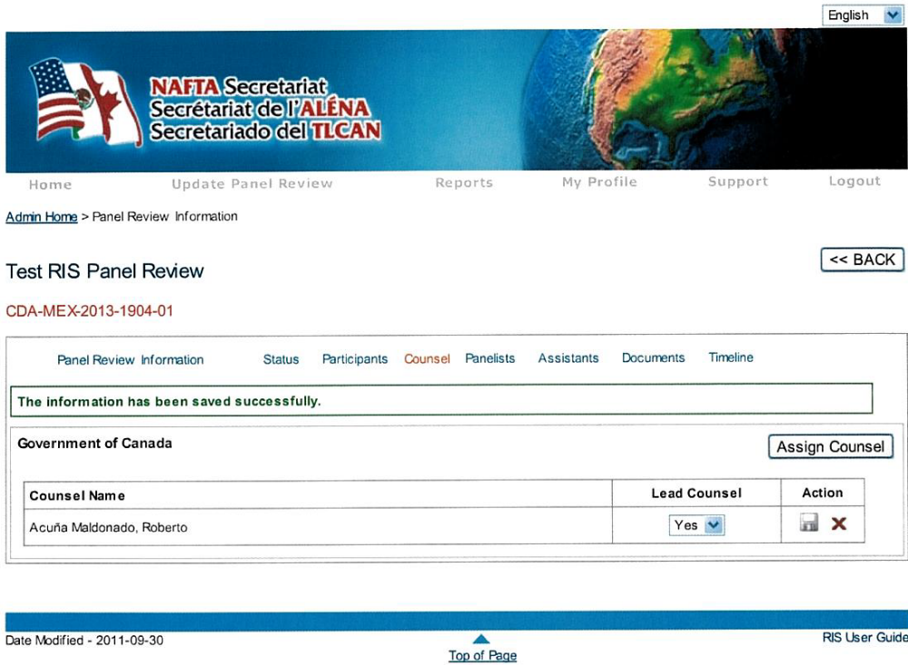
Notice how the counsel has been assigned to “Government of Canada”.

If the participant has more than one counsel representing them, multiple counsels can be assigned at once by scrolling down the list and by selecting the pertinent checkboxes. There is no limit to the number of counsel users can assign to a participant.

3.1.3 Add Panelists

Once the panel selection has been established by the Parties, panelists can be added to the panel review by selecting the “Panelist” tab. The following screen

will be presented:
By default, there will be no panelist associated to the panel review. To add a panelist, select the “Add Panelist” button.

Upon selection, the following screen will be displayed:

To search for a panelist, type their full or partial name in the “Search” field and click on the magnifying glass.

A search can be performed to locate the panelist associated to this panel review. Enter full or partial first or last name in the “Search” field and click on the magnifying glass to launch the search. The list will automatically refresh, and then select the checkbox of the appropriate panelist. Multiple panelists can be added at once by scrolling down the list and by selecting the checkboxes of as many panelists as required.

Once the checkbox has been selected, specify the “Selection Date” and press “Add Panelist”.

Remember to enter the selection date of the panelist.

Select the appropriate panelist via the select box and then press “Add Panelist”.

After the panelist has been added to the panel review, the screen automatically refreshes. From here, the user can specify the “Withdrawn Date”, the status and if this panelist is considered the “Chair” (click on the diskette to save any changes made to this screen). Additional panelists can be added by selecting the “Add Panelist” button on the right-hand side of the screen.
Remember to click on the diskette to save any modifications.

Note that by default the panelist’s “Status” is “Active” and the “Chair” option is set on “No”.

3.1.4 Assign Assistants

Once the panelists have been added to the panel review, users can associate who their assistants are.

To add an assistant, select the “Assistant” tab. The following screen will be displayed and notice how only those panelists that have previously been added to the panel review are listed.
To assign an assistant for a panelist, select the “Assign Assistant” button located to the right of the panelist name. The following screen will be presented:

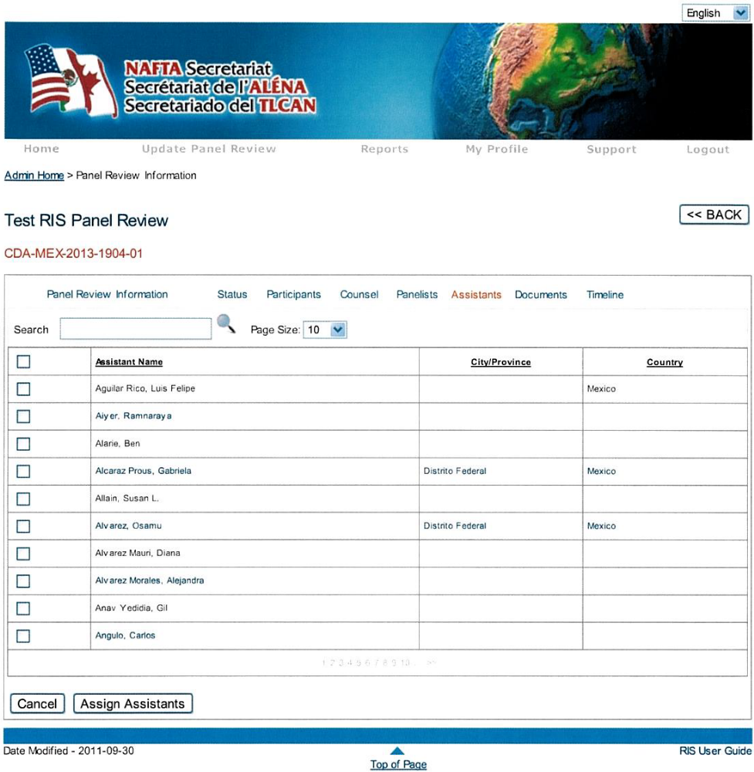
Select the appropriate assistant via the select box and then press “Assign Assistants”.

A search can be performed to locate the assistant to be associated to a panelist. Enter full or partial first or last name in the “Search” field and click on the magnifying glass to launch the search. The list will automatically refresh, and then select the checkbox of the appropriate assistant. Multiple assistants can be added at once by scrolling down the list and by selecting the checkboxes of as many assistants as required.

Once the checkboxes have been selected, press “Assign Assistants” and the following screen will be presented.

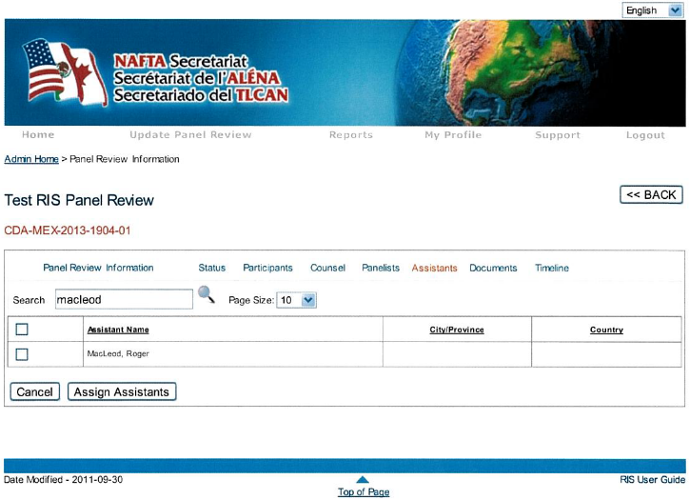

3.1.5 Add “Request for Panel Review”

The “Request for Panel Review” can be added to the docket sheet while in the process of creating a new panel review by selecting the “Documents” tab. See Section 3.2.1 – Document Management for further instructions (p. 18).

3.2 Update Panel Review

Panel review data can be updated at any time by selecting “Update Panel Review” from the top level navigation bar or by selecting the icon of the RIS homepage.

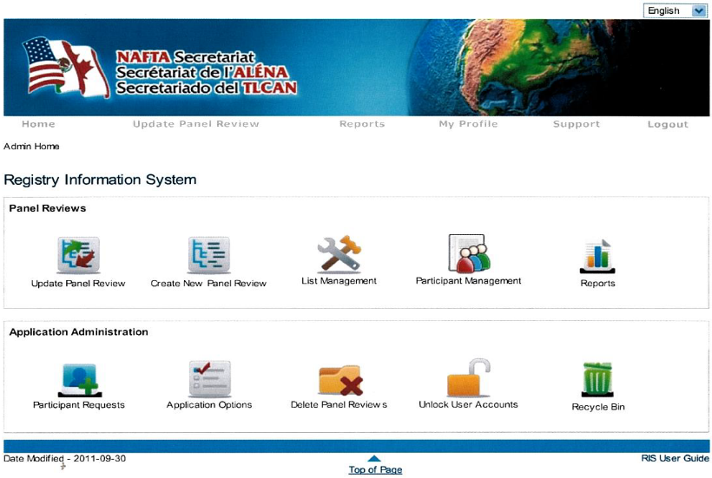
Use either option.

c

From here, the user can search for the panel review that needs to be updated by either typing the full or partial title or panel review number in their respective search fields and hit “Enter” or “Search”. However, please keep in mind that there are already pre-selected options (such as responsible Secretariat, year, status…) that may narrow down the search considerably.

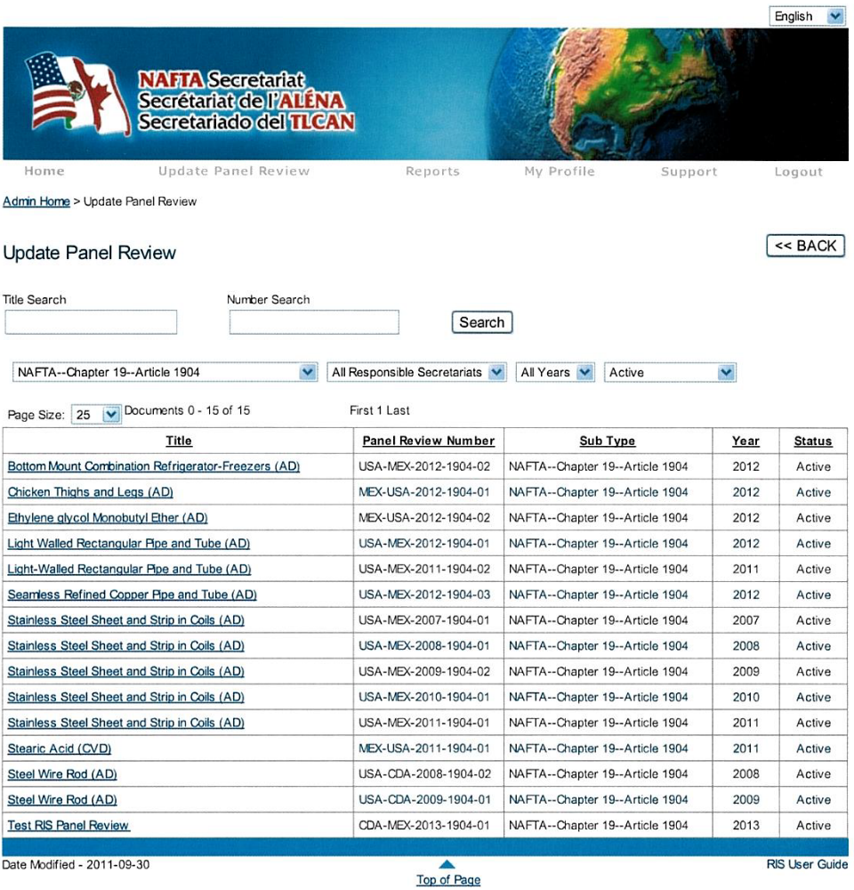

These parameters are set by default, but can be changed to offer a variety of filtering options.

To select the panel review, click on its “Title”

c
c
Click on the category title of any given column to change the sequential order.

Once the panel review has been located, select it by clicking on the panel review “Title” from the list and the panel review details will be displayed as outlined in Section 3.1 of this user guide (see figure on p. 7).

3.2.1 Document Management

Documents can easily be added to the docket sheet of any panel review at any time by selecting the “Update Panel Review” module from the top level navigation bar or by selecting the icon on the RIS homepage. Then select the appropriate panel review number, and once the screen refreshes, select the

“Documents” tab. The following screen will be presented:

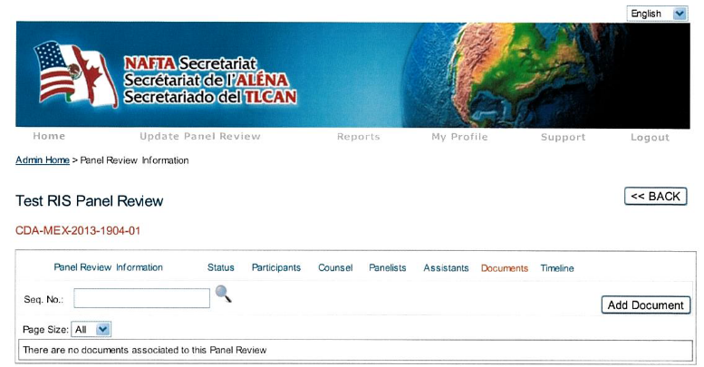
A search by document number can be performed (click on the magnifying glass to launch the search).

Initially there will be no documents associated to the panel review.

c

3.2.1.1 Add Document

To add a document, select “Add Document”. The following screen will be presented:

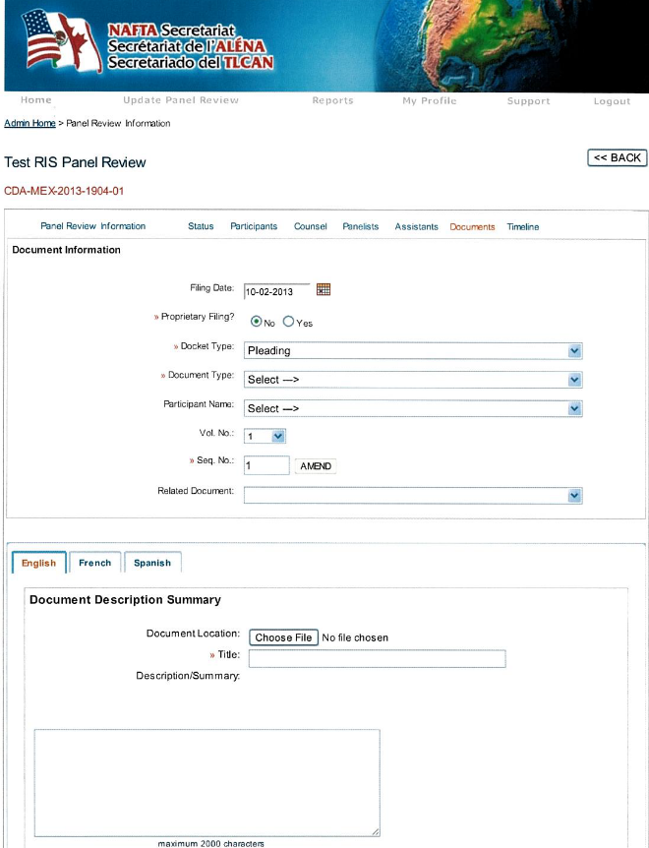
Toggle through these tabs to add the translated PDF version of the document.
Although the “Description / Summary” is not mandatory, it’s always best to fill in this field as the information gets populated in some reports (e.g.: “Docket Sheet” Report).

c
The “Spell Check” feature depends on the web browser used to open the RIS application.

I would like to Serve this document
Save
Once the form is completed, always remember to « Save » it.
<< BACK
c

The form above allows users to specify various details about the document, for instance, the filing date, if the document is proprietary or not, the docket type (pleading or correspondence), the document type (and sub-type if they exist for the document selected type), the participant name, in which volume a document was filed (not an automated function for obvious reasons) and if it relates to any other documents previously added to the docket sheet (such as motions, responses and orders).

Note that all sequence numbers are auto-generated and cannot be changed; however, the “Amend” button allows users to add a document in between previously added documents. For example, if a document is introduced between document numbers 4 and 5, the sequence will be displayed as 4.1.

Furthermore, only non-proprietary documents should be uploaded in a PDF version or scanned (PDF) by selecting the “Choose File” button to locate the file in your system (it’s imperative not to upload documents in other formats). N.B.: Translated PDF version(s) of a document can also be uploaded within the same document (or sequential number) by toggling through the “language” tabs and uploading the PDF in the same manner as described above. In other words, there is no need to add a new document, in the docket sheet, for each available PDF version.

3.2.1.2 Add Decision

Upon adding a “Decision” to the docket sheet, the screen refreshes to display the following options: “Affirmed” or “Remand”. (The “Affirmed” option is selected by default.)

Upon selecting the “Remand” option, the screen refreshes once more to display the “To Be Determined” option as well as four possible scenarios. Note that there is a direct link between the timeline and the “Remand” option. The user should initially select the “To Be Determined” option until it is known that records have been supplemented or not and that the decision has been challenged or not.

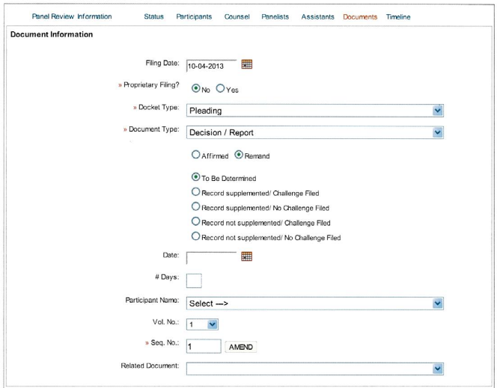
Select either the date selector or enter the number of days specified in the panel decision. Upload the PDF version of the decision by selecting the “Choose File” button and “Save”.

c
The timeline will be adjusted automatically upon selection of one of these four scenarios.
c

N.B.: Once the PDF version of a decision has been uploaded in RIS, by selecting the “Choose File” button, the “Panel Review Decisions” under the “What’s New?” section of the NAFTA Secretariat website is simultaneously updated. Furthermore, the decision is simultaneously published in the “Panel Decisions and Reports” of the “Dispute Settlements” section of the NAFTA Secretariat website, and as such, immediately available to the public.

3.2.1.3 Modify Document

To modify a document, from the “Document” tab, select the “pencil” relating to the document requiring modification. The screen refreshes to display the document form, make the necessary changes and “Save”.

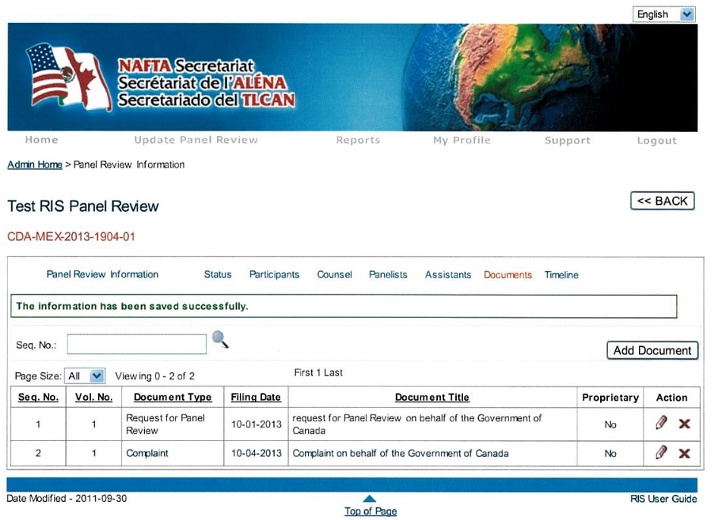
c
c

3.2.1.4 Delete Document

Caution: To delete a document, from the “Document” tab, select the “X” sign relating to the pertinent document; however, note that the document information as well as the sequential number will be permanently deleted from the docket sheet.

3.2.2 Timeline

As previously mentioned, the timeline is automatically generated upon setup of the panel review (3.1 – Step One). To view the timeline, select the “Timeline” tab. The following screen will be presented:

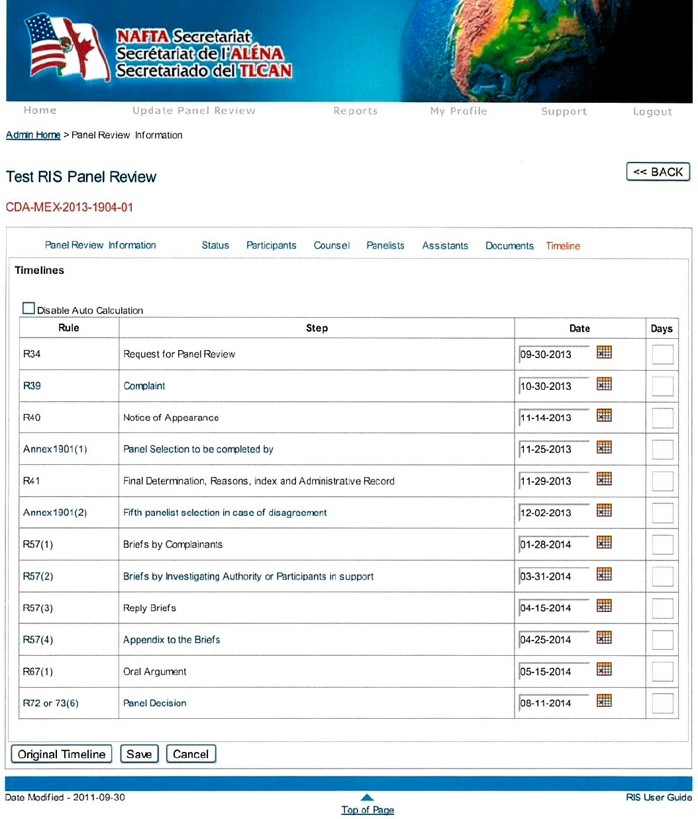
c
To disable the timeline from auto calculating, select this checkbox.

c
Change the date by checking off the “Days” box - a field to specify the number of days for an extension will then be provided. Based on the number of days specified, the date will update accordingly.

Change the date by selecting the date selector.

c
Press “Save” to apply any changes made to the timeline.

c

To change a date, select the date selector. Note that if a holiday or weekend is specified, the timeline will auto-calculate the date forward to the next business day.
To disable the timeline to auto-calculate, select “Disable Auto Calculate”. Alternatively, to adjust the date by specifying a specific number of days, select the “Days” checkbox. This will open a field layer that enables users to specify a number of days. The timeline will recalculate based on the selection.

If at any time users wish to view the original timeline, select the “Original Timeline” button.

3.2.3 Status

The status of the panel review may be updated at any time by selecting the “Status” tab. The following screen will be presented:

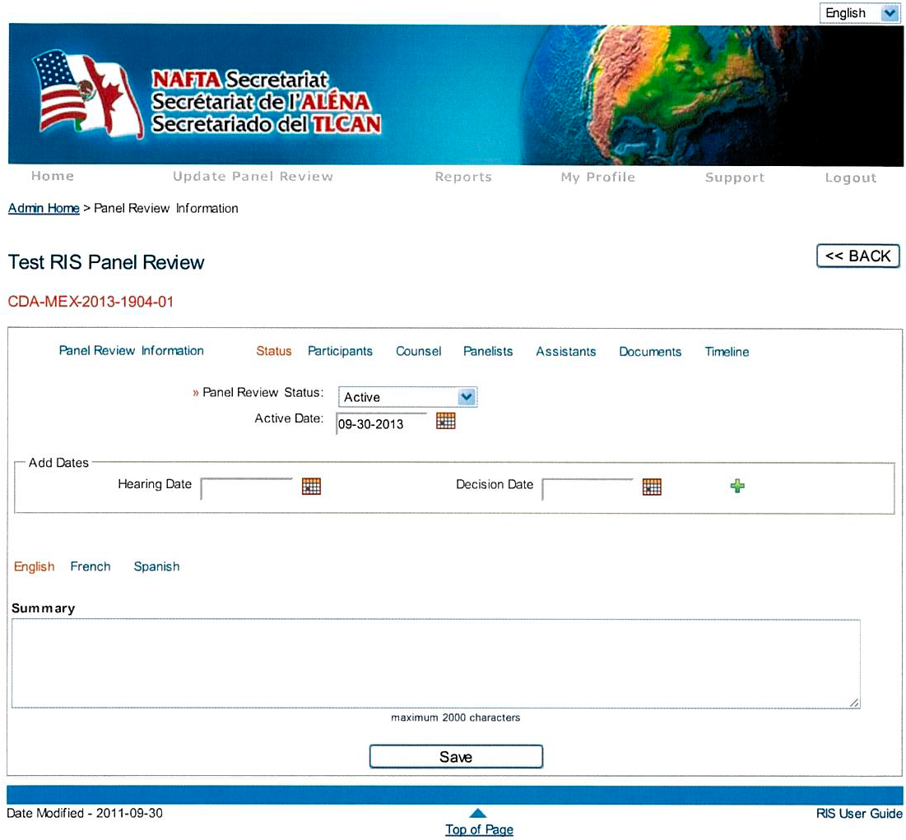
By default the status is set at “Active”. However, it should be updated when a Panel Review is suspended/stayed, terminated, completed or joined.

Within the tab, users can change the “panel review status” to reflect whether the panel review is: active, completed, joined, suspended/stayed or terminated. When a new status is selected, a field will be presented to collect the date of the status change as per the figure on the next page:
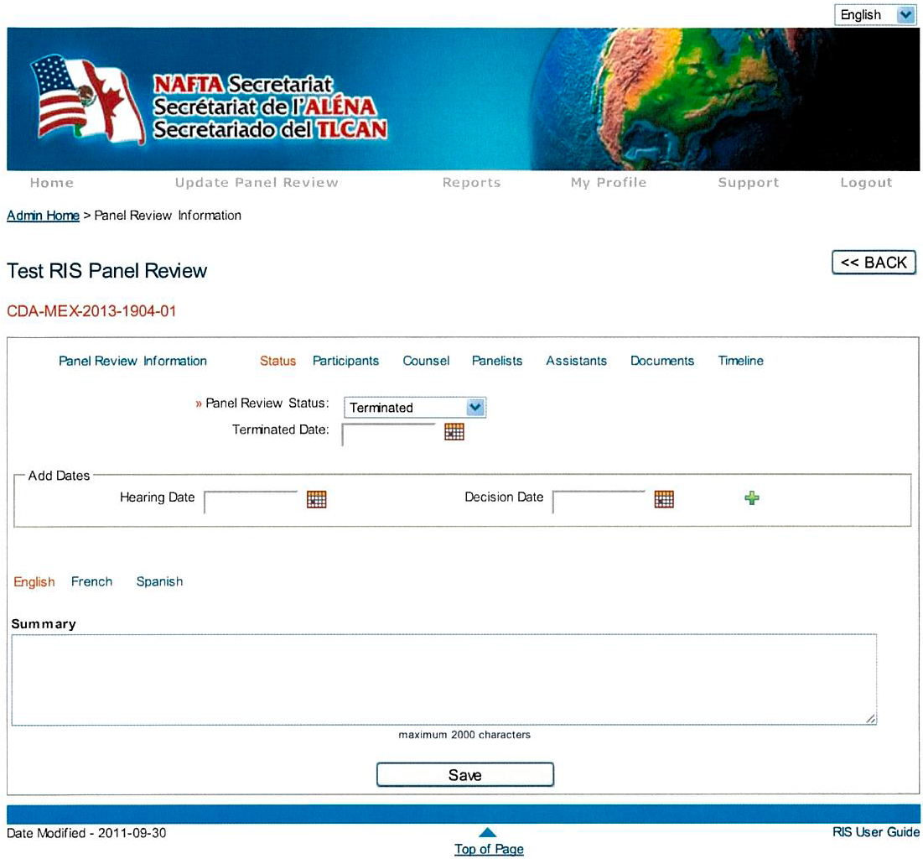
Selecting a new status from the drop down menu will open a field to collect the date of the status change.

c
Press “Save” to apply any changes made to the Status.

c

New hearing dates and decision dates can be captured. To do this, simply specify the “Hearing Date” and/or “Decision Date” (from the “Add Date” section) and click on the “+” sign which will trigger a new series of fields to be displayed, as per the figure below:

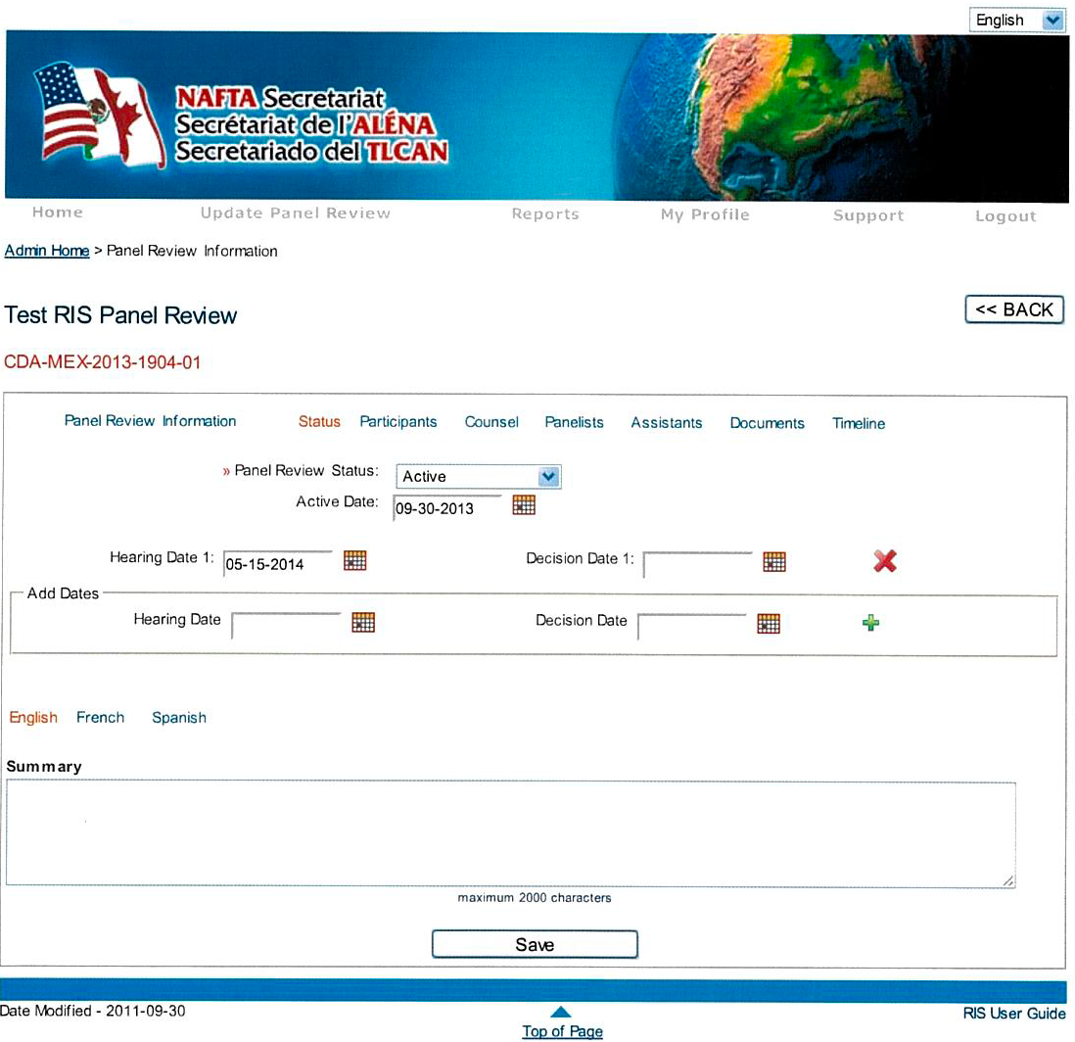
To apply the changes, press the “+” sign.
c
Add a Hearing Date by selecting the date selector.
c

3.3 Delete a Panel Review

Panel reviews can be deleted by selecting the “Delete Panel Review” module from the RIS homepage as outlined below:

c

Upon accessing the module, the following screen will be presented:
c
c
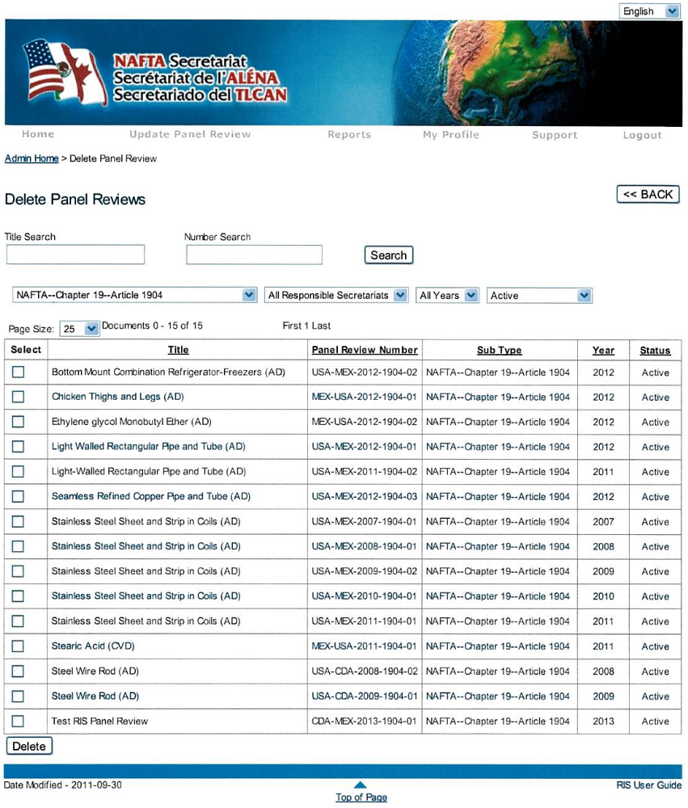
c
By default all active panel reviews are displayed. Select the appropriate panel review and press “Delete”.

Various filtering options may be used to locate a specific panel review.

Select the appropriate panel review via the select box and then press “Delete”.

Note that the selected panel review is not permanently deleted; it is rather sent to the “Recycle Bin” module as a safeguard measure. While it remains in the “Recycle Bin”, all the information pertaining to the panel review can either be restored (republished in RIS) or removed permanently.

Keep in mind that while it remains in the “Recycle Bin”, the panel review number cannot be reused hence impeding the sequential order of subsequent panel reviews.

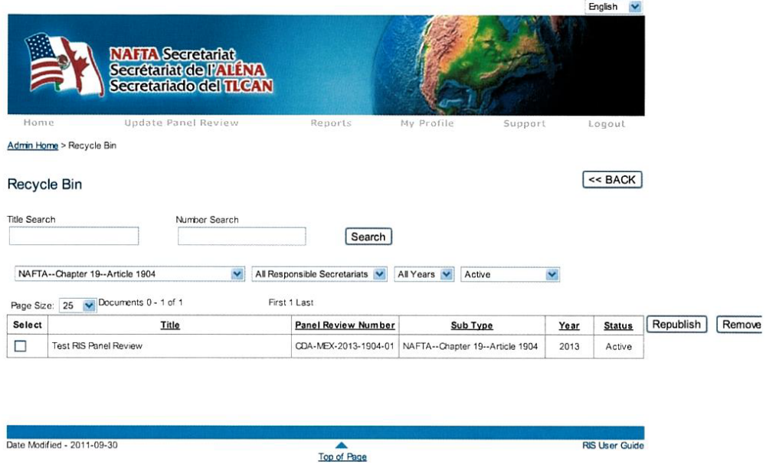
Select the appropriate panel review and press “Republish” or “Remove”, as required.

c
c
c

4.0 Lists Management Modules

4.1 “List Management” and “Participant Management”

4.1.1 List Management

The “List Management” is a centralized location used to setup profiles for counsels, panelists and assistants. The counsel, panelists and assistants profiles must first be entered into the “List Management” database prior to creating or updating a panel review.

This module is accessed via the RIS homepage as per the figure below:

c

4.1.1.1 Add Counsels, Panelists and Assistants

To add a counsel, a panelist or an assistant, “Select a Role” (Counsel, Panelist or Assistant) from the drop down menu and make a thorough search of the list to avoid creating a duplicate entry (unfortunately, duplicates cannot be permanently deleted from the database as they are associated to other panel reviews).

If users are confident the individual is not on the list, select “---I am a NEW User---”. Fill in all the mandatory fields and “Save”.
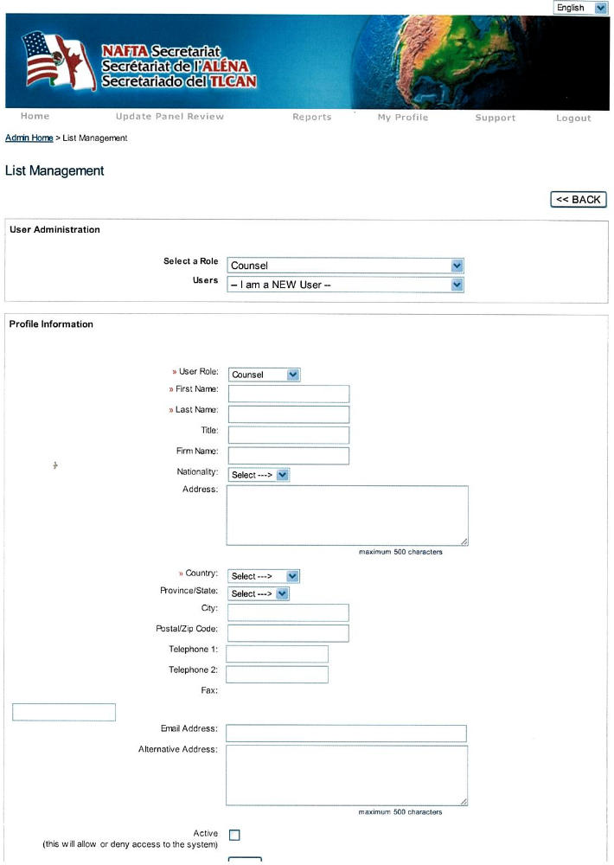
This feature was created in order to “activate” or “deactivate” user accounts - these accounts once created can never be permanently deleted from the “List Management” module. Remember to select the “Active” checkbox upon creating a new user account and “Save”.
This field is only mandatory when creating accounts for NAFTA Secretariat employees as it allows them to receive their log in information.

c
c

4.1.1.2 Account Management for NAFTA Secretariat Employees

The “List Management” module is also used to setup accounts for SuperAdmins, Administrators, PowerUsers and Parties (their roles are defined in more details under Section 2.0 of this user guide).

To setup accounts for new NAFTA Secretariat employees, select the “Administrator” or “PowerUser” role and select the “---I am a NEW user---” option, fill in the mandatory fields as well as the “Email Address” field. Select the “Active” checkbox to allow the NAFTA Secretariat employee to access the RIS.

Upon saving the profile information form, an email is auto-generated and forwarded to the new user providing him/her with a “User Name” and a “Password”. It’s always best for the new user to modify their randomly selected password to something easier to remember, go to “My Profile” - top level navigation bar.

Note that these accounts can never be deleted; however, the access to the RIS can be denied at any time by removing the check mark of that particular account user.

If the employee has forgotten his/her password, he/she should click on “Forgot your Password?” link on the RIS Login screen. At which point, the user will be prompted to enter his/her “User Name” and then answer a security question. A password will be re-generated and sent to the user by email. The user can then log in and go into “My Profile” and change the randomly selected password to something a little easier to remember.

If the employee has forgotten his/her username, he/she should advise their respective national section Administrator. The Administrator can log into RIS and access the user’s account through the “List Management” module. Once the user is found, click on “Generate New Password”. An email is auto-generated and sent directly to the user email address (initially setup in his/her profile).

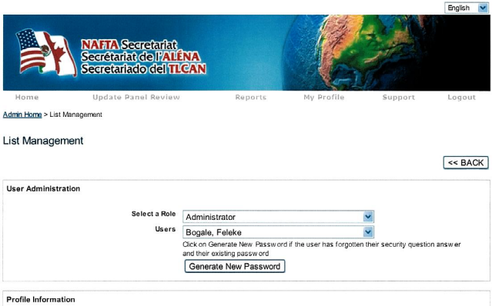
c

4.1.2 Participant Management

This module is solely used to setup profiles for Participants. The participant profile must first be entered into the RIS database prior to creating or updating a new panel review. Users cannot add new participants to the “Participant Management” module from within a panel review.

This module is accessed via the RIS homepage as per the figure below:

c

4.1.2.1 Add Participants

To add a new participant to the “Participant Management” database, select the “Participant Management” module from the RIS homepage (see Section 4.1.2 above). The following screen will be displayed:

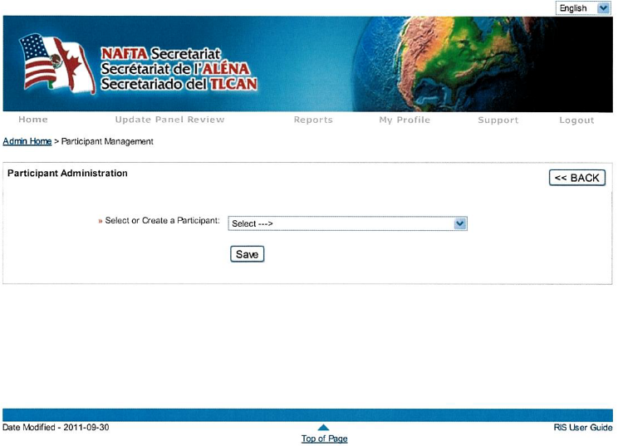

Make a thorough search of the list to avoid creating a duplicate entry (Note that duplicates cannot be permanently deleted from the database as they are associated to other panel reviews). If users are confident the participant is not on the list, select “”---I am a NEW participant---” from the drop down menu. This will open the following “Participant Administration” form:

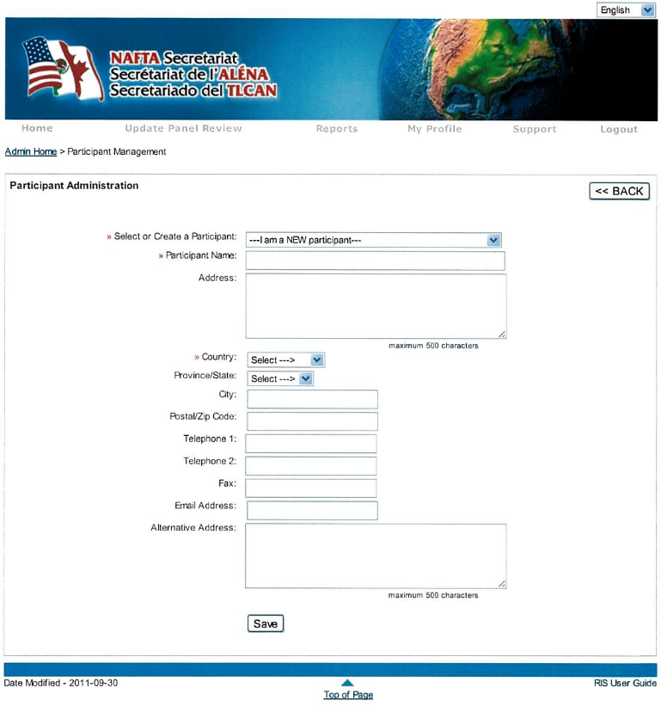

Only the “Participant Name” (i.e.: company name, industry …) and “Country” are mandatory fields on this form; however, it is highly recommended that users provide as much information as possible for any participant to be added to the database.

4.1.2.2 Modify Participants

To modify the profile details of a participant, select the “Participant Management” module from the RIS homepage (Section 4.1.2.).

Search for the participant by scrolling down the list of the “Select or Create a Participant” field. Once located, select the participant and modify the profile details as required. Note that modifying the profile details of a participant will update the participant profiles in all panel review they have been assigned to. Finally, press “Save” to apply the changes.

5.0 Reports

The RIS provides a number of reports related panel reviews. To access the RIS reports, select “Reports” from the top level navigation bar or from the icon located on the RIS homepage.

Use either option.

c

The following screen will be displayed:

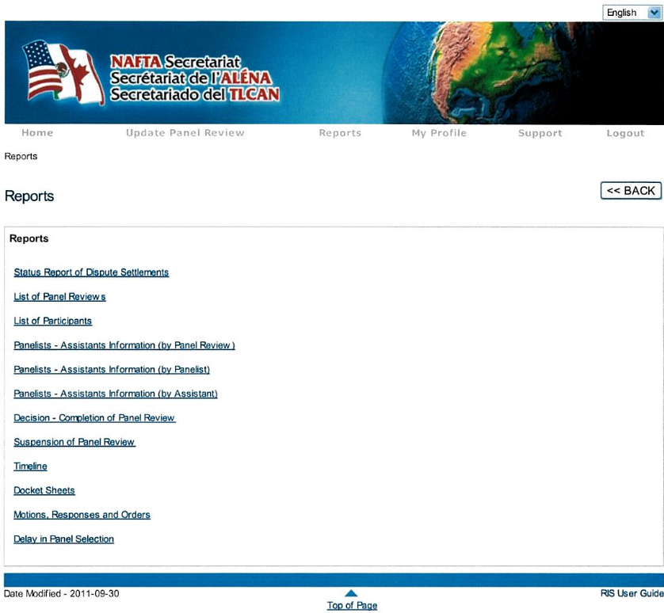

To generate a report, select one from the list presented and remember that the reports are as accurate as the information captured into the RIS. Each report includes a variety of filtering options to generate the report as required. After a report is generated, a “printable” version of the report can be printed. This feature is located in the upper right corner of the report output.

6.0 Application Options

Application options are available to both Super Administrators and Administrators. Application options allow users to further configure the RIS application settings. To access the “Application Options” module, select the icon from the RIS homepage.

Upon selection, the following screen will be presented:

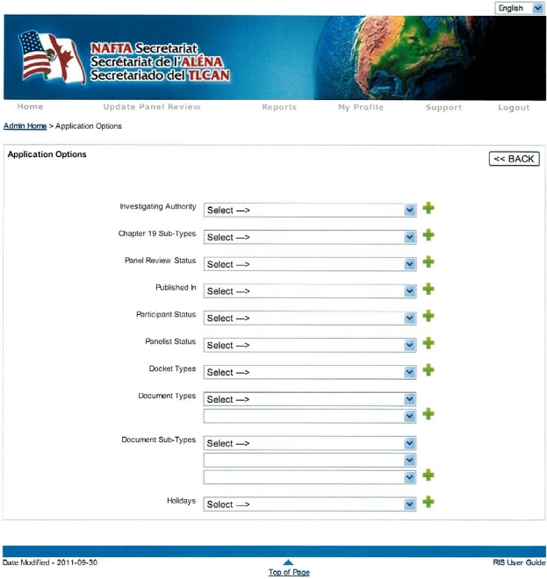

Items can be added to each category and each category can be modified.

These categories are described below:

Investigating Authority: | This option enables users to add and modify investigating authorities that can be selected from when setting up a new panel review.
Chapter 19 Sub-Types: | This option enables users to add and modify sub-types that are presented when creating panel reviews of the Chapter 19 variety.
Panel Review Status: | This option enables users to add new panel review statuses that can be selected from throughout the life cycle of any given panel review.
Published In: | This option enables users to add and modify selections that are provided in the “Final Determination” information section of the panel review.
Participant Status: | This option enables users to add and modify participant statuses.
Panelist Status: | This option enables users to add and modify panelist statuses.
Docket Types: | The system supports two docket types: Pleading and Correspondence. If there is ever a requirement to add new docket types, users can access this option.
Document Types: | This option enables users to add and modify new document types by panel review type (i.e.: NAFTA 1904, ECC, Suspension, etc.). These are then displayed to users as selections when adding documents to any given panel review. The “Editing” field offers additional options, for instance, to displays documents in the “Related Document” field of the “Documents” module or to release specific document types to the public.
Document Sub-Types: | This option enables users to add and modify document sub-types for each panel review type. These are displayed to users as selections when adding documents to any given panel review.
Holidays: | This option enables users to add and modify holidays that are accounted for in generating the timelines.

7.0 Participant Requests

The “Participant Requests” module was created for the purpose of the NAFTA e-filing pilot project, if and when approved, to provide Counsels to Participants access to a specific Panel Review to file and serve their documents as well as to view and download documents pertaining to the specific panel review number they have been assigned to.

It is through this module that the Super Administrators and Administrators approve or deny a participant’s request to register to the NAFTA e-filing system. It is also through this module that Super Administrators and Administrators authorize or deny filed documents to be served to other case participants.

8.0 Unlock User Accounts

Access the "Unlock User Accounts" module whenever a user account has become locked as a result of an excessive number of failed login attempts. If the user still fails to log into the system, access their profile in the “List Management” module and “Generate New Password”.

9.0 Recycle Bin

Deleted panel reviews are moved to the “Recycle Bin” until they are permanently deleted from the database, refer to Section 3.3 - Delete a Panel Review for additional information.

10.0 Support

The “Support” button from the top level navigation bar is an email format used to inform “Super Administrators” and “Administrators” of any technical issues a user may have encountered while using the RIS.

